Türkalp KUCUR
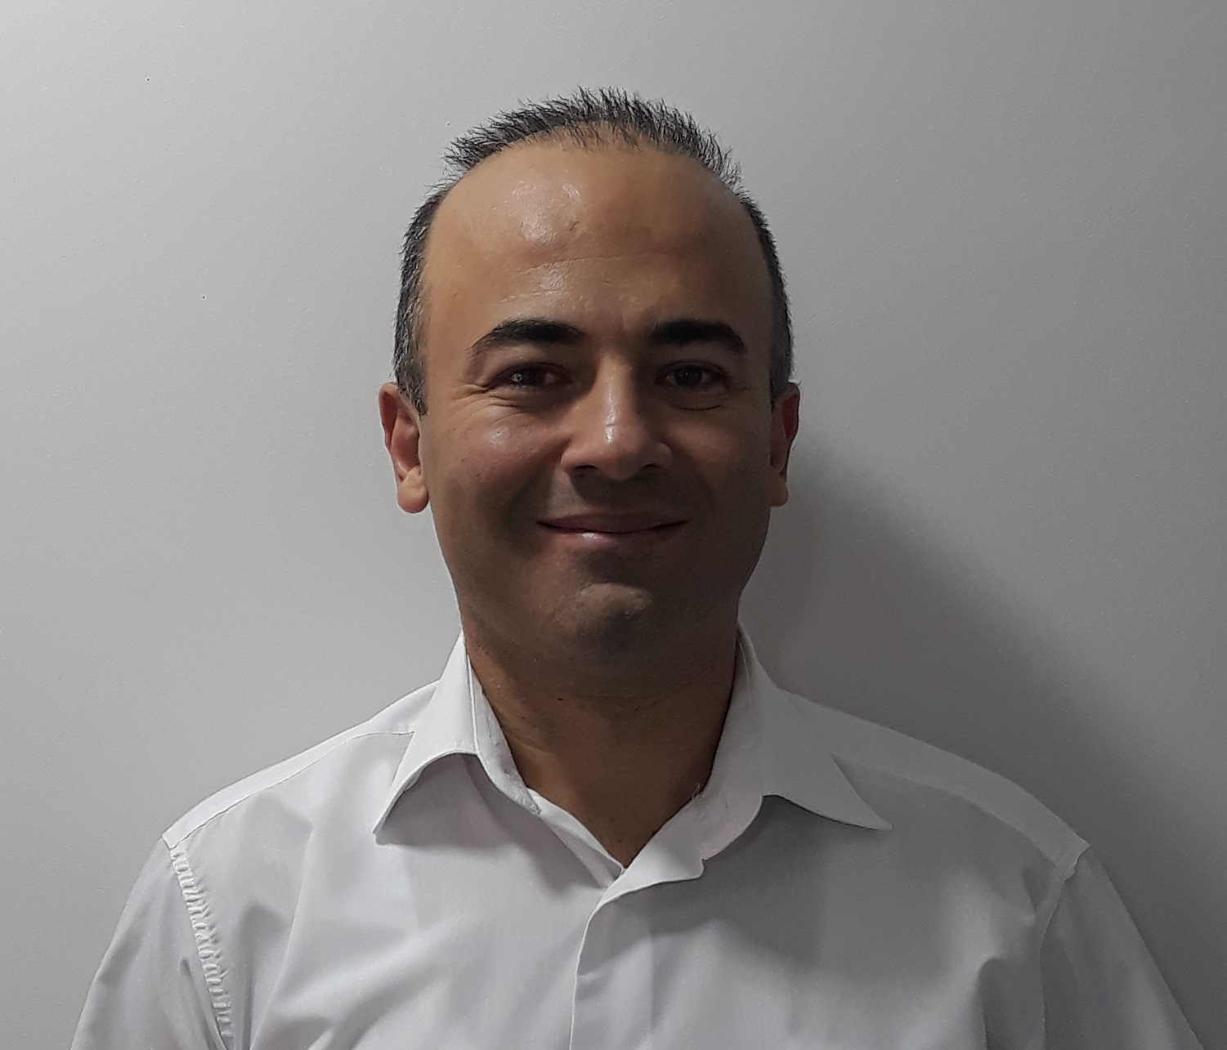
📍 Istanbul (Anadolu Yakası), Türkiye
📞 0505 427 01 23
✉️ turkalp.kucur@gmail.com
🔗 https://www.linkedin.com/in/t%C3%BCrkalp-kucur-9a3777b8/
🔗 https://github.com/turkalpkucur

PROFILE

With 20 years of professional software engineering experience, I have developed software using C#, MS SQL, PostgreSQL, and REST API technologies. I have served as a Team Lead and Software Architect, building healthcare, CRM, and enterprise applications, and I continue to do so.

I focus on developing high-performance, scalable, cloud-based, and sustainable software solutions. By adhering to software architecture principles, keeping up with the latest technologies, and leveraging AI tools where appropriate to improve efficiency, I build modern software solutions. I have worked as a Senior Developer using both Waterfall and Agile methodologies.

I enjoy solving problems.

Software development does not end with delivering the product. Over the years, I have gained extensive experience in crisis management, problem analysis, delivering fast and permanent solutions, and effective time management. I am a team-oriented developer with strong problem-solving skills and the ability to quickly learn new technologies.

I enjoy continuous learning and actively follow emerging technologies.

Currently, I am focused on learning AI algorithms while also improving my skills in frontend and mobile development.

As a sociable person, I value making the best use of my time. Rather than watching TV, I enjoy electronics and RC (radio-controlled) hobbies. I also enjoy staying active through sports.

---

## TECHNICAL SKILLS

### Backend
- C#
- .NET 8
- ASP.NET Core Web API
- Entity Framework Core
- Dapper
- LINQ

### Databases
- PostgreSQL
- Microsoft SQL Server
- Redis

### Frontend
- React
- Next.js
- TypeScript
- JavaScript
- jQuery
- HTML5
- CSS3

### Mobile
- Native Android Development
- React Native

### External Tools
- Telerik Controls
- DevExpress Controls

### DevOps & Tools
- Docker
- Git
- GitHub
- IIS
- Nginx

### Notification Systems
- Ably

### Architecture
- Clean Architecture
- Onion Architecture
- CQRS
- Repository Pattern
- Dependency Injection
- Microservices

### Domain Expertise
- CRM
- Accounting
- ERP Systems
- Payment Systems
- Social Media
- WhatsApp Business API

### Certifications
- Bilge Adam Software and Database Expertise (2012–2013)
- Kariyer Mimarı Android Development (2013)

### Languages
- English: B2 (Reading, Writing, Speaking)

---

# PROFESSIONAL EXPERIENCE

## Infotec Bilişim
**Senior Full Stack Developer**
**01/2022 – Present**

### Responsibilities
- Developed and maintained cloud-based applications.
- Worked on both frontend and backend development.
- Designed and implemented new features, reporting systems, and backend services.

### Projects

**Wease.io Lead Management System v1**
- Developed the complete frontend and backend of the cloud-based platform.
- Implemented WebRTC, reporting, Ably integration, and webhooks.
- Added video calling functionality using React.
- Developed calendar and reporting tools.

**Technologies**
- Backbone.js
- .NET Core 3.1
- Microsoft SQL Server
- Monolithic Architecture

**Wease.io Lead Management System v2**
- Developed features within a layered Microservices architecture using CQRS.
- Worked on reporting, Ably integration, and webhooks.
- Developed frontend forms using Next.js.
- Participated in the development of backend services for the insurance module.

**Technologies**
- .NET
- Microsoft SQL Server
- PostgreSQL
- Dapper
- React

### Features
- Authentication & Authorization
- Dynamic Reporting
- Sales Tracking
- Task Management
- Project Management System

---

## Mega Code
**Senior Full Stack Developer**
**09/2018 – 12/2021**

### Responsibilities
- Developed enterprise web applications.
- Implemented new features.
- Fixed software defects.
- Analyzed customer requirements.

### Projects

**Acente365 Insurance Platform**
- Cloud-based monolithic application.
- Developed frontend and backend.
- Built forms, reporting modules, background services, and notification systems.

**Sea365 Maritime Catering Portal**
- Cloud-based monolithic application.
- Developed frontend and backend.
- Built forms, reporting modules, background services, and notification systems.

**Dijipol Insurance Portal**
- Microservices-based backend development.
- Developed background services and notification systems.

### Technologies
- .NET
- PostgreSQL
- Dapper
- React

### Features
- Authentication & Authorization
- Dynamic Reporting
- Sales Tracking
- Task Management
- Project Management System

### Additional Technologies
- .NET
- Microsoft SQL Server
- React

---

## Akınsoft
**Software Development Team Lead**
**04/2018 – 09/2018**

### Responsibilities
- Led the development of a cloud-based accounting software project.
- Successfully completed the beta version of the project.

### Technologies
- .NET
- PostgreSQL
- Dapper

### Features
- Authentication & Authorization
- Dynamic Reporting

---

## Crt Yazılım
**Full Stack Developer**
**01/2014 – 04/2018**

### Responsibilities
- Migrated the CRM application from Silverlight to ASP.NET MVC.
- Worked on both frontend and backend development.

### Technologies
- .NET
- Microsoft SQL Server

### Features
- UI Design and Development
- Backend Services
- Authentication & Authorization
- Dynamic Reporting

Additionally, I developed native Android mobile applications for software used by two law firms.

---

## Emko Emaye
**Junior Developer**
**09/2009 – 12/2013**

### Responsibilities
- Developed screens for the company's internal ERP software.
- Worked as a Junior Developer on an electronic smart board system.

### Technologies
- .NET
- Microsoft SQL Server

